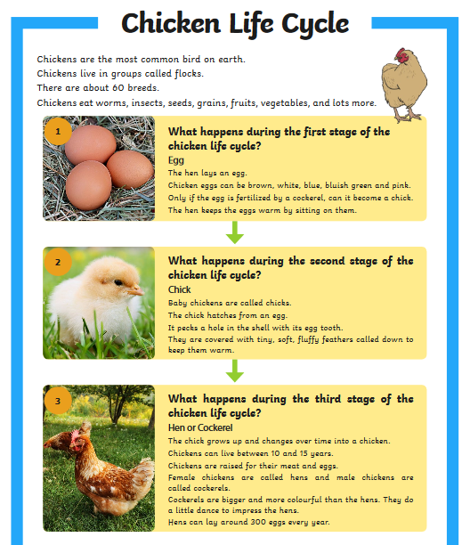
Questions:
- What are the groups that chickens live in called?
______________________________________________________________________________
- How many breeds of chicken are there?
______________________________________________________________________________
- Name 2 things that chickens eat.
______________________________________________________________________________
- What colour can eggs be?
______________________________________________________________________________
- How do hens keep the eggs warm?
______________________________________________________________________________
- What are baby chickens called?
______________________________________________________________________________
- What does the chick do with its egg tooth?
______________________________________________________________________________
- How long do chickens live?
______________________________________________________________________________

