Reading Choice Board
Read a book on the couch  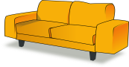 | Read a book with a silly voice   |  | Build a fort and read a book inside the fort.  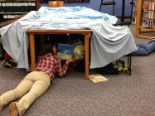 |  | Read a book about zoo animals  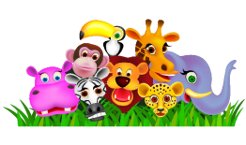
Read a book with a flashlamp.   | Read a book outside.   |  | Read a story to your favourite teddy, action figure or doll.  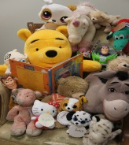 |  | Read a book with a quiet voice.  
Read a counting book   | Read a book by your favourite author |  | Read a book in your bedroom  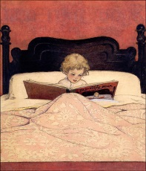 |  | Read a book under a tree  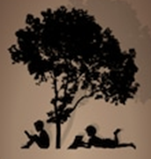
Read a book under a blanket   | Read a book about bugs  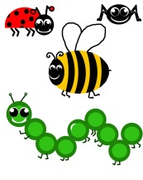 |  | Read a book on the grass (if it’s dry)   |  | Make a little seat with some books and read another book    (This one is too high!)
Read a book with  Super heroes in it.  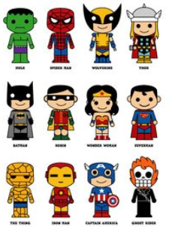 |  | Read a book on a comfortable chair.   |  | Read a book to your teddies.  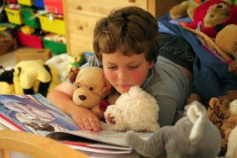
Read a story to your pet or to your toy pet animal  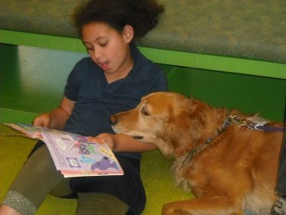 |  | Sit on the ground with your legs crossed to read a book.   |  | Read a comic book or a magazine.  